**Mapping ecosystem services flow from the three protected areas in the Far-eastern Himalayan landscape: An impetus to regional cooperation**

**Abstract**

Ecosystem services concept is an essential tool to promote integrated conservation and development especially, in the context of landscapes where, ecological, economic, and socio-cultural resources are connected. The concept is useful to understand that benefits of ecosystems often flow to distant beneficiaries, even inter-regionally beyond the boundaries of one nation. Our study capitalizes on this concept of interregional ecosystem services flow between the three countries- China, India and Myanmar in the Far-eastern Himalayan landscape. We used participatory Geographic Information System (GIS) mappingto visualize ecosystem services flow from the three protected areas in the landscape, and participatory scenario analysis to understand the plausible direction for protected area management. The Service Provision Hotspots (SPHs), Service Beneficiary Areas (SBAs), and Degraded Service Provision Hotspots (dSPHs) were mapped for selective ecosystem services of high management priority. The prioritized services were then assessed under three plausible scenarios - Nature-at-Work, Nature-People-Harmony, and People-at-Work to understand trade-offs between them. This relationships between thesource and the sink of ecosystem services, and perfrmances of services under different scenario provided a strong evidence and argument for regional cooperation between the three countries.We recommend the need for developing an intra, inter-countries, and regional partnerships mechanisms for the future sustenance of ecosystem services from PAs in the landscape.

***Keywords*:** Regional cooperation; Participatory GIS, Participatory scenario, Service provisioning hotspots; Service beneficiary areas; Hkakaborazi National Park; Namdapha National Park; Gaoligonshan National Nature Reserve

**1. Introduction**

Ecosystem services or nature’s contribution to people relate to use and benefits of biodiversity (MEA, 2005; Fisher et al., 2009) therefore closely linked to both ecological and socio-economic development discourses (Hummel et al., 2019). Ecological objectives maintain ecosystem health for longer term provisions of services while socio-economic objective maintain health and well-being of people. Protected areas (PAs) have been the key instrument for biodiversity conservation (Chape et al 2005), and ecosystem services concept have furthered their scope and values beyond this primary objective of conservation (Braat & Groot, 2012). The usefulness of ecosystem services for effective conservation planning is well acknowledged (Chan et al., 2006). PAs now stand for the sustenance of wider ecosystem services such as livelihoods development, climate change adaptation and mitigation, health provisioning, water and food security, natural disaster reduction, tourism and economy promotion, research and education, and promotion of cultural values (Raymond et al., 2008).

The ‘Programme of Work on Protected Areas’ of the Convention on Biological Diversity stresses on enhancing ecological, economic, cultural and social benefits from PAs, including the processes of participatory decision making, co-management, and regional cooperation for their management (Coad et al., 2012). However, operationalizing ecosystem services perspective for effective management of PAs is challenging (Schirpke et al., 2017) mainly because ecosystem services perspectives are often explored within a narrow bio-physical boundaries and its interregional dimensions are overlooked (Koellner et al., 2019). Often, areas providing the services and areas benefitting are distant and dislocated (Syrbe & Grunewald, 2017) and it is difficult to measure ecosystems’ capacity to produce services, the pressures that hampers ecosystem’s ability to provide the services, and the societal demand for the services (Villamagna et al., 2013). In the context of landscapes where geophysical, ecological, socio-cultural resources are connected, understanding interregional dimensions of ecosystem services (Schröter et al., 2018) is crucial, as they provide strong evidence of flow of ecosystem services from the origin to the beneficiaries (Bagstad et al., 2013), thus facilitate effectivebiodiversity and ecosystem services governance (Kissinger et al., 2011).

,-China, India, and Myanmarthe are scale of , This paper attempts to explore spatial relationship between where the services arises and are used, what factors are deteriorating the services, and how could services possibly change under certain scenarios. The primary aim was to develop a shared understanding among decision makers, PA managers, and other stakeholders in the landscape - about wider values of PAs, compare services between PAs in different countries, and essentially help countries explore joint interventions for protection and improvement of ecosystem services. The literature on ecosystem services confer on the knowledge that the spatial extent of supply and demand for services, and the extent of overlaps between service provision and service beneficiaries areas (Serna-Chavez et al., 2014; López-Hoffman et al., 2010) are vital for developing effective management strategies for PAs and biodiversity outside them (Guerry et al., 2015); and that direct and indirect contributions of ecosystems (TEEB, 2010), including understanding of trade-offs and synergies between services (Turkelboom et al., 2018) help strike the balance between objectives of conservation and sustainable development (M Schröter et al., 2018). We attempt to build such knowledge for the landscape, subsequently exploring the context of interregional flow of services to trigger regional cooperation between the three countries for long-term sustenance of biodiversity and ecosystem services in the landscape.

**2. Study areas**

The study was carried out in the three protected areas - Gaoligongonshan National Nature Reserve (GNNR) in Yunnan, China; Namdapha National Park and Tiger Reserve (NNP-TR) in North-east India; and Hkakaborazi National Park (HKNP) in Northern Kachin, Myanmar. The three PAs along with Hponkanrazi Wildlife Sanctuary in Kachin, Myanmar form a contiguous ecological landscape in the north-western part of of the Far-eastern Himalayan Landscape (Fig. 1.). The transboundary landscape has been jointly identified by the International Centre for Integrated Mountain Development and partners in the three countries to promote regional cooperation for integrated conservation and development (ICIMOD 2019).

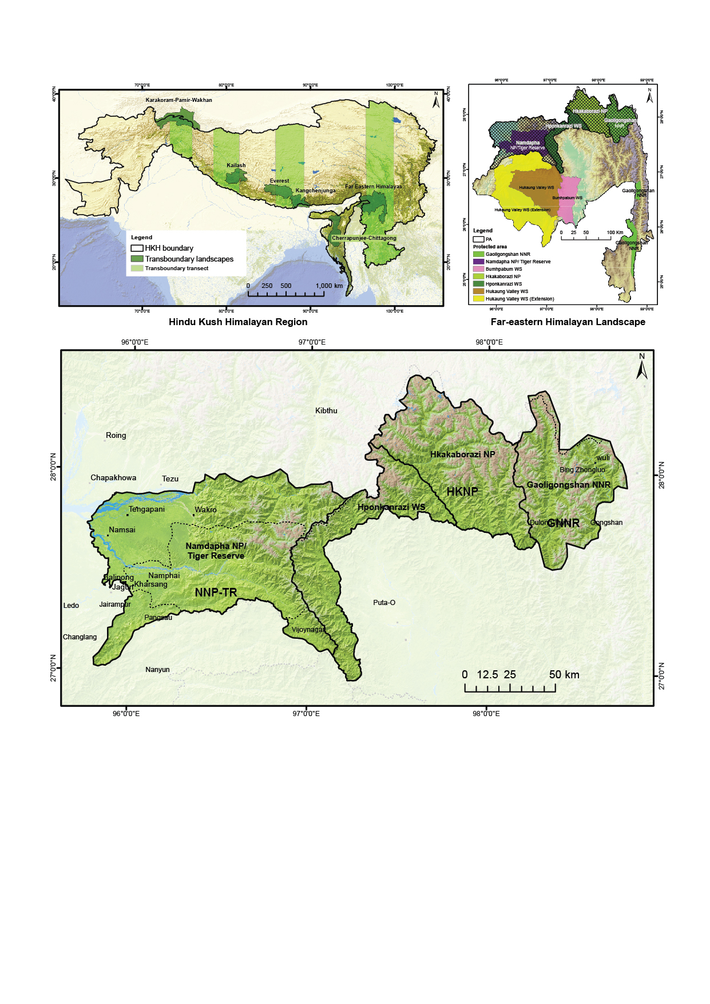

**Fig. 1.** Study areas in the three countries. The Far-eastern Himalayan Landscape (top right map) is one of the six transboundary landscapes identified in the Hindu Kush Himalayan Region (top left map) to facilitate integrated conservation and development interventions. It has seven PAs. This study concerned the three major PAs (bottom map): Gaoligonshan National Nature Reserve in China (GNNR), Hkakaborazi National Park in Myanmar (HKNP) and Namdapha National Park and Tiger Reserve in India (NNP-TR).

The Far-eastern Himalayan Landscape incorporates approximately 71,000 sq km of area comprising Gaoligaongshan range in north-western Yunnan of China in the east, the Namdapha Tiger Reserve and adjoining areas of North-east India in the west, and in between seven townships in the Kachin state of Northern Myanmar. The landscape as a unit is one of the most intact and biodiversity rich transboundary complexes within the Hindu Kush Himalayan Region that hosts biodiversity elements of the three global biodiversity hotspots- the Himalayan, the Indo-Burman, and the South-West China (Shakya et al., 2011). The Northern Myanmar Forest Complex in the northernmost part hosts pristine old growth forests (Renner et al., 2007), whereas the Himalayan and Gaoligongshan ranges bring in both n, including rich mineral and gem deposits. The complex topography combined with diverse climatic conditions make the landscape suitable for a wide range of floral and faunal assemblages that portray high degree of endemism (Behera et al., 2002).

The GNNR includes the contiguous forest ridges west of the Nujiang River and east of the Irrawadi-Nmai Hka Rivers, and is part of the Indo-Burma biodiversity hotspot (Chaplin, 2005). It was established in 1983 as a provincial nature and converted to national nature reserve in 1986. The NNP-TR is a national park and is one of the largest PAs in India (area-wise). It is the only National Park in the state of Arunachal Pradesh having a dual status of a national park and a tiger reserve, and covers a geographical area of 1,985 km2 with 1,808 km2 core zone and 177 km2 of buffer zone (Lodhi & Samal, 2013). The HKNP is gazetted as national park in 1996, and is named after the snow-capped Hkakaborazi mountain- the highest peak in Southeast Asia (5,881 m). It is located in Naung Mung Township in Putao District of Kachin State, Myanmar.

**3. Methods**

transdisciplinary knowledge co-production approach (Rist et al. 2007) to sensitize A three-step harmonized method comprising participatory identification of ecosystem services of top management priority, participatory mapping of ecosystem services flow (Palomo et al., 2013), and participatory scenario-based assessment of prioritized ecosystem services (Palomo et al., 2011) was followed for all the three PAs. Knowledge co-production was facilitated through three stakeholder’s workshops in China, India and Myanmar where a total of 122 participants contributed with respective representation share of 29%, 34% and 37% between the countries. Given that the social learning is more explicit and effective with mixed group of participants (Garcia-Nieto et al., 2019), we ensured that participants in all three workshops were a mixed group of representatives from government departments (protected area managers, ministries and line departments), research and academic institutions, development practitioners from international organizations and non-governmental organizations, community members, and private sector institutions. ES assessments are mostly complex, and we needed to keep the method simple to capture as much stakeholders’ value and local dynamics (Young et al., 2013), GIS maps, PCA (Principal Component Analysis) bioplot, and Excel charts were used to visualize the results. Details of each step is given below:

**Step 1: Participatory identificationof ecosystem services of top management priority**

The participants in the workshop were asked to list range of ecosystem services from the chosen PAs in their respective countries. The services were grouped under provisioning, regulating, cultural, and supporting following MEA (2005). Participatory ranking exercise was done to identify ecosystem services of the highest management priority - that is ecosystem services needing the most immediate management attention. A harmonized indicator oriented scoring was performed to assess vulnerability and of the prioritized ecosystem services. Indicators for vulnerability included status of current conditions, likely future supply-demand, extent of drivers and factors influencing services, and availability of enabling policy and management support. Usefulness indicators outlined extent of users, scale of beneficiaries, immediate market benefit, and prospect for intrinsic value.



**Step 2: Participatory mapping of flow of services**

Ecosystem services identified in step 1 were used for participatory GIS mapping. ., is said to bring , and help engage both societal experts (community groups living in and around the PAs) who are often excludedin conservation and PA management dialogues, , and disciplinary experts (academia / government decision makers, thematic experts) who develop management strategies, and facilitate PAs programs implementation (Hummel et al., 2017). An A0 sized printed maps showing PAs boundary and adjoining areas were used for mapping exercise. Participants were asked to use colored pins and locate Service Provisioning Hotspots (SPHs), Services Beneficiary Areas (SBAs), and degraded Service Provisioning Hotspots (dSPHs) in the map as per their knowledge, expertise, and experience. Blue pins were used for SPHs, , yellow pins for SBAs red pins for dSPHs. . Discussion points were added as qualifier information. Each point represented key area of significance in terms of either source or sink, and areas where ecosystem services are under threat. A vertical digital photographs of the maps with pins were taken for each of the prioritized ecosystem services. The digital image was The The **Step 3: Participatory scenario planning and assessment of priority services**

Participatory scenario planning is a useful tool to create a common vision, improve decision making, and foster cooperation (Biggs et al, 2007). Scenarios are increasingly being used in PA management (Brown et al. 2001), and regional planning (Peterson et al. 2003). They have been regarded useful in creating a plausible descriptions of how future might unfold on a coherent set of assumptions about key elements and drivers of change (Carpenter et al., 2005). We approached participatory scenario planning for PAs following Palomo et al. (2011) but with slight improvisation. The improvisation was the harmonization of three plausible scenarios – Nature-at-Work (protection oriented), Nature-People-Harmony (adaptive view), and People-at-Work (extraction oriented). The harmonization was necessary to make result comparative across the three countries. However, characteristics for the three scenarios were defined by each country based on their respective national PA and conservation policy directives. Lastly, performance of prioritized ecosystem services under each scenario was assessed using a 0-10 scoring frame with 0-4 indicating full degradation of services or limited provision, 5-7 indicating satisfactory provision, and 8-10 adequate provision.

**4. Results**

**4.1. Ecosystem services of top management priority from the three PAs**

All (MEA, 2005)were listed - 25 from GNNR, 21 from NNP-TR and 20 from HKNP. . a wealth cultural were listed. dicated a fodders, The ability for the pristine landscapes with diverse topographic regimes to create right ambience for species productivity, evolution, and diversification was placed as supporting services.

The ranking exercise with the extensive list of services revealed four ecosystem services of high management priority (Table 1). These included: provisioning services (mainly relating to medicinal plants and genetic resources), cultural services (mainly relating to tourism and recreation, education and knowledge and aesthetic and heritage significance), habitat regulation (relating to provision and maintenance of habitat for important biodiversity and ecological function) and water regulation (relating to both provision of water, and maintenance of water quality and flow).

|  |  |  |  |
| --- | --- | --- | --- |
| **Table 1**  Top four ecosystem services of highest management priority from Gaoligonshan National Nature Reserve (GNNR), Namdapha National Park/Tiger Reserve (NNP/TR), and Hkakaborazi National Park (HKNP). The percentage in the bracket is the ranking score. | | | |
| **Ecosystem services** | **GNNR (China)** | **NNP/TR (India)** | **HKNP (Myanmar)** |
| 1. Provisioning of medicinal plants/genetic resources | Medicinal plants (63%) | Genetic resources and medicinal plants (50%) | Medicinal plants (35%) |
| 2. Cultural services of recreation, education and heritage | Education and knowledge (50%); Recreation (47%) | Tourism and recreation (37%) | Heritage value and knowledge (27%) |
| 3. Habitat regulation | Habitat provisions (41%) | Habitat for important biodiversity (53%) | Habitat for ecological and evolution function (32%) |
| 4. Water provision and regulation | Provision of water (23%) | Water flow and cycle maintenance (31%) | Fresh water provision (62%), Water regulation (58%) |

In terms of cumulative vulnerability and usefulness of the four prioritized services (Figure 2), it was evident that all services had higher vulnerability score range of 69-94% and usefilness score range of 77-96%. The perception was that all services catered to multiple users with beneficiaries at local-national (within the country), regional (across landscape) and global scale (beyond the three countries). For example, the a –including

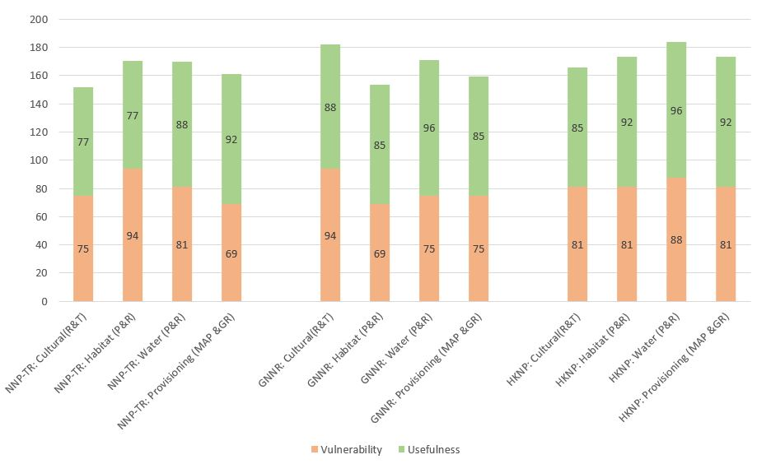

**Fig. 2.** Cumulative vulnerability and usefulness score of four prioritized services in three PAs.

All four services were regarded to have non-monetary intrinsic value contributing to higher usefulness. With regard to vulnerability, the participants reflected that while the demand for all four services will increase in future, the supply could decline given the influence of both localized and global drivers of change. Comparing between the countries, average vulnerability for GNNR (about78%) is less compared to other two PAs in the landscape. For HKNP, average scores for both vulnerability and usefulness was the highest among the three PAs.

**4.1. SPHs, SBAs and dSPHs for four services**

**Provisioning services**

Altogether 89 SPHs points (Fig. 3a) were evident both inside and outside of PAs- with 93% of representation of SPHs within the three PAs. The SPHs reflected range of vegetation, ecosystems and biodiversity rich areas. About 39 SBAs (Fig. 3b) with 72% of representation reflected settlements in or at the vicinity of PAs. Local communities living in and near PAs were regarded as major beneficiaries in terms of acquisition of provisioning services- manly for their daily household use, and for farms and income. About 28% of SBAs were found to be located away from PAs- these reflected beneficiaries located at distant urban centres or across borders where biodiversity resources are used. The dSPHs (Fig. 3c), mostly highlighted areas of human settlement both inside and at the outskirts of the PAs with 90% and 10% representation respectively - where high value medicinal plants were more intensely collected for commercial purpose. . The dSPHs also indicated border areas between the two countries, where reseources are unsustainably and haphazardly extracted for trade, particularly between China and Myanmar. Areas of timber felling and deforestation for agricultural expansion were also explicitly mentioned under dSPHs, especially for HKNP and NNP-TR.

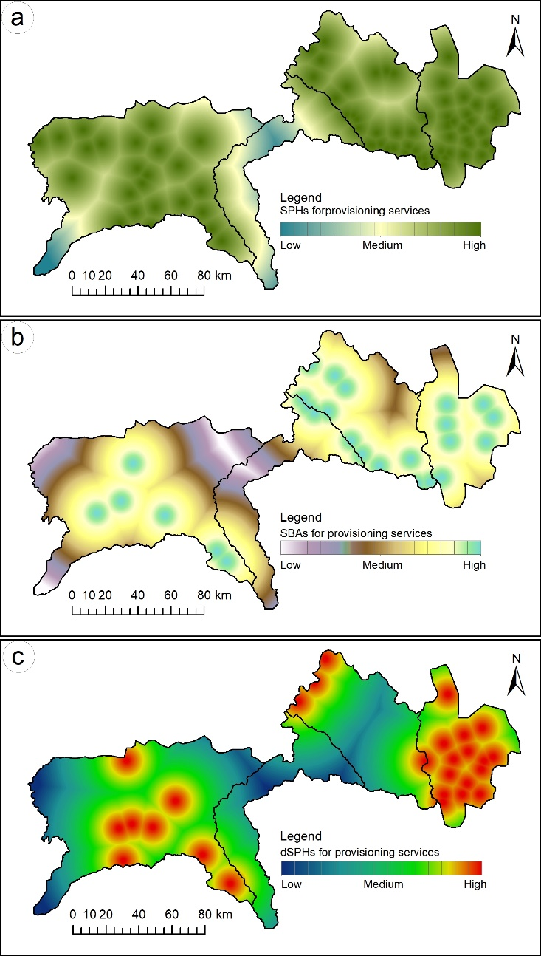

**Fig. 3.** The SPHs (a), SBA (b) and dSPHs (c) for the provisioning services in the three PAs.

**Cultural services**

About 78% of the SPHs for cultural services (Fig. 4a) were inside PAs. These reflected areas with pristine habitats and unexplored biodiversity, and abode of indigenous and ethnic communities in the landscape - Han, Yi, Bai, Lisu, Nu, Dulong in GNNR; Rawang, Lisu, Kachin, Tarong in Myanmar; and Jingpaw, Lisu, Chakmas in India. The SPHs also indicated naturally, culturally and historically significant spaces within the PAs that held spiritual values, and provided cognitive and educational benefits - such as sacred forests in NNP-TR, areas used by almost vanishing Tarong tribe in HKNP, and ethnic Dulong communities in GNNR. About 28% of SBAs (Fig. 4b) appeared beyond the PAs that highlighted cultural services of global scientific value- especially academia interested on knowledge of rich biodiversity in the three PAs. Other SBAs included recreation and tourism sites and natural scenic spots catering to both domestic and international tourists and travelers.. The dSPHs (Figure 4c) accounting to 83% of representation within PAs highlighted areas of socio-cultural conflict and areas where traditional systems of local communities are deteriorating, The dSPHs outside PAs mainly highlighted areas with unplanned development infrastructures.

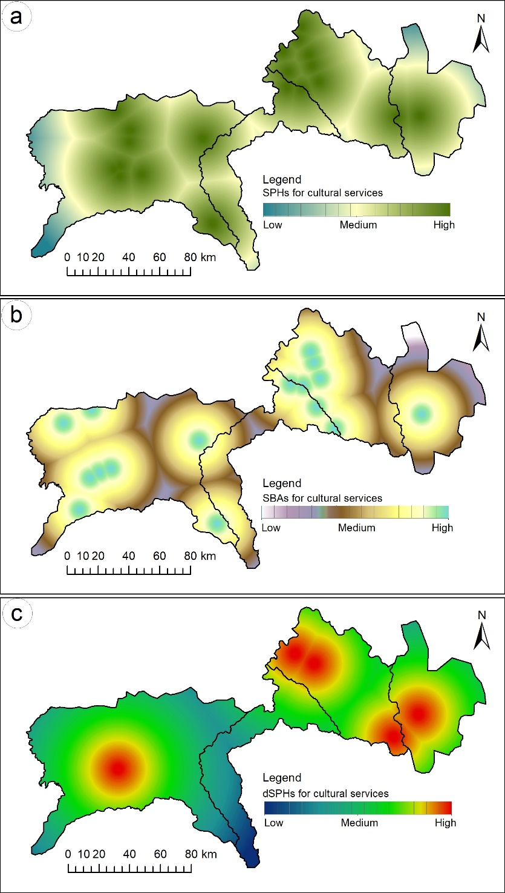

**Fig. 4.** The SPHs (a), SBA (b) and dSPHs (c) for the cultural services in the three PAs.

**Habitat services**

The SPHs for habitat services (Fig. 5a) reflected habitats that hosted landscape’s major flagship species such as tiger (*Panthera tigris*), elephants (*Elephas maximus*), and other globally endangered fauna such as takin (*Budorcas taxicolor*); leaf deer (*Muntiacus putaoensis*); black muntjac (*Muntiacus crinifrons*); red panda (*Ailurus fulgens*); asiatic black bear (*Ursus thibetanus*) and stump-tailed macaque (*Macaca arctoides*), hoolock gibbon (*Hylobates hoolock),* temminck’s tragopan *(Tragopan temminckii).* About 15% of SPHs points were featured outside PAs, and were refrred to as key biodiversity areas with several of them located in the Hponkanrazi Wildlife Sanctuary connecting NNP-TR and HKNP. The SPHs in NNP-TR highlighted habitat of globally threatened and migratory black-necked crane (*Grus nigricollis*), blyth's tragopan (*Tragopan blythii*), black-faced warbler (*Abroscopus schisticeps*), and other rare species such as root parasitic plant- *Sapira himalayana* (Adhikari et al. 2003; Srinivasan et al., 2010). The SPHs for GNNR were pristine and most diverse vertical mountain vegetations that hosted number of endemic species (Lan & Dunbar, 2000). Likewise, for HKNP, the SPHs included areas that define distribution of ecologically and aesthetically important mammals - - for example the Nam tarnai river serves as a natural barrier for the distribution of hoolock gibbon which are mainly located on the west side of the river, and the black barking deer (*Muntiacus crinifrons*) are restricted to the east side (Tun, 2001). Participants identified SBAs (Fig. 5b) to be well preserved forested areas with undisturbed vegetation, and which hosted endemic and rare species, and served as hotspots for key flora and fauna such as rhododendron *(Rhododendron giganteum* - the largest rhododendron in the world in GNNR), orchids (*Paphiopedilum wardii* – the black orchid), and migratory birds. These SBAs indicated areas of species protection and distribution, yet 41% SBAs were located outside the PAs. With regard to dSPHs (Fig. 5c), they were less prominent for GNNR and HKNP, as primary vegetation were considered to be intact, whereas for NNP-TR, 71% representation of the dSPHs highlighted areas of unmonitored vegetation clearing, and land encroachment for settlements, and about 29% of dSPHs were located outside PAs.

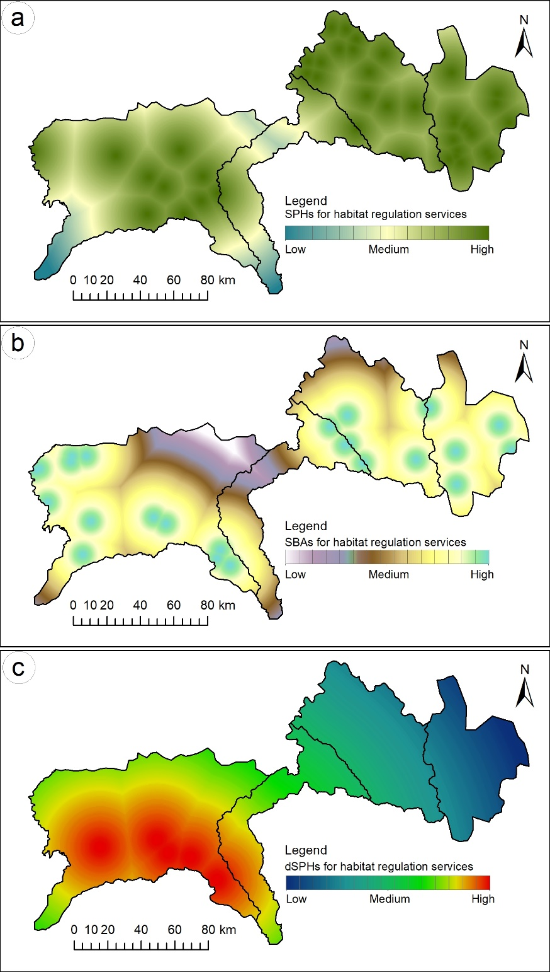

**Fig. 5.** The SPHs (a), SBA (b) and dSPHs (c) for the habitat services in the three PAs.

**Water services s**

The forested watersheds, several wetland ecosystems including snow covered mountain peaks, glaciers, and alpine lakes were marked as the SPHs for water provisioning / regulation services (Fig. 6a)- with 72% SPHs representation inside the PAs. The HKNP adjoining the GNNR presented a most complete vertical bioclimatic belt serving as water tower for entire Myanmar. The PAs in the landscape altogether fed water to three major rivers –Brahmaputra in India, Ayeyawady in Myanmar, and Salween river in China. The SBAs for water services (Fig. 6b) represented both local settlement areas along the valleys where water is used for daily household and farm work, and populations residing outside of PAs (52% representation) where water regulations services were vital to sustain rivulets and river systems nourishing downstream areas and population. to the dSPHs (Figure 6c) with 80% of their representation inside PAs included areas where land erosion, forest degradation, deforestation, including haphazard timber extractions were occurring, For Myanmar dSPHs were the areas of dam construction.

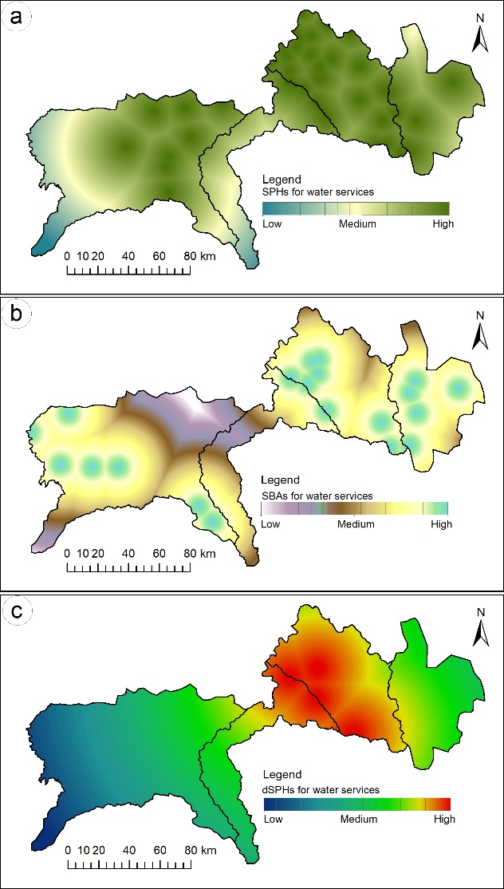

**Fig. 6.** The SPHs (a), SBA (b) and dSPHs (c) for the water services in the three PAs.

**4.1. Participatory scenario planning and assessment of four ecosystem services**

Existing policy and management directions were used to define logic for each of the three plausible scenario. GNNR is currently managed as a Strrict Nature Reserve, and the policy direction is towards zonation and creation of national park along the lower elevation of Gaoligong mountain to aid both biodiversity protection of economic development. HKNP is a national park, and the policy direction is towards strengthening community based conservation to meet dual objectives of conservation and sustainable development. NNP-TR is currently both a national park and tiger reserve, and policy direction is towards expanding the buffer areas to mitigate conflict over land resources and their use by ethnic communities. Table 2 describes the three scenarios for each PA.

|  |  |  |  |
| --- | --- | --- | --- |
| **Table 2**  Logic for each scenario for the three PAs as outlined by participants during the workshops | | | |
| **GNNR** |  | | |
| Nature-at-work | GNNR remains as strict nature reserve, several lower elevation areas also brought under strict management; Traditional land management practices totally prohibited hence impacts cultural and agricultural resources; Protection dominated by government rules and strict regulation; Greater investment towards non-nature based livelihoods | | |
| People-Nature-Harmony | GNNR core zone preserved as strict nature; lower stretch managed as national park where cultural and conservation-linked economic opportunities are allowed; development infrastructure to have ecological considerations; wise use of technological innovations; zone specific plans and policies; exploration of income through payment of ecosystem services | | |
| People-at-Work | GNNR core zone preserved as strict nature; other areas remain as zone of economic growth; Booming of tourist and use of commercial products, haphazard development infrastructure | | |
| **NNP-TR** | | | |
| Nature-at-work | NTR core zone is totally protected and has no communities inside; Settlement avoided in the buffer zone; Conflict among ethnic community for land tenure thus aggravates. | | |
| People-Nature-Harmony | NTR cores zone is well protected with positive engagement from community living inside; Buffer zone expanded and used as a multifunctional landscape; Tourism flourishes and promotes local culture and nature based ecotourism | | |
| People-at-Work | NTR core zone faces further land encroachment and extraction of resources increases; Settlement in the outskirts of PA grows and development infrastructure provide wider opportunities for commercial tourism development and business | | |
| **HKNP** |  | | |
| Nature-at-work | HKNP is managed as national park managed strictly under government plan and policies, other areas around are also converted into protected areas with limited access to use of resources; Resource use for economic benefit strongly controlled. | | |
| People-Nature-Harmony | HKNP landscape and biodiversity are well maintained as national park, expansion of southern extension as community conserved areas where co-management is practiced; Communities have diversified livelihood interventions; nature and culture based tourism promoted; Sustainable landuse, energy, and water related technologies strengthened | | |
| People-at-Work | HKNP remains as national park, but resource extraction and degradation is not monitored adequately; Business and development infrastructure is promoted for enhancing the livelihoods of local communities, but there are more gains for stakeholders from outside; Trade based on natural resources increases | | |
|  |  |  |  |

The scores of four services against the three scenario (Figure 7) showed that for all three PAs, the most favourable scenario is ‘Nature-People-Harmony’where all services are maintained in moderations and trade off between the services are minimial. The other two scenario at the two extremes of conservation-economic spectrum showed certain trade-offs among the services – for example for GNNR, Nature-at-Work scenario seem to enhance habitat and water services but compromised provisioning of essential commodities for the communities and therefore also cultural services related to communities traditional knowledge and practices around conservation and use of natural resources. Likewise, People-at-Work scenario with higher economic orientation, provisioning and cultural services were better but at the cost of habitat and water services.

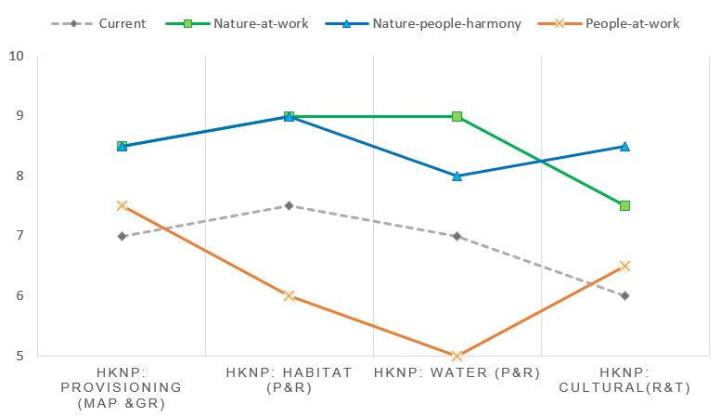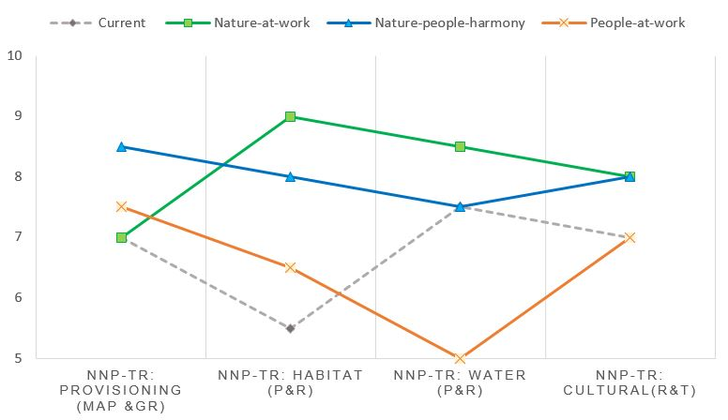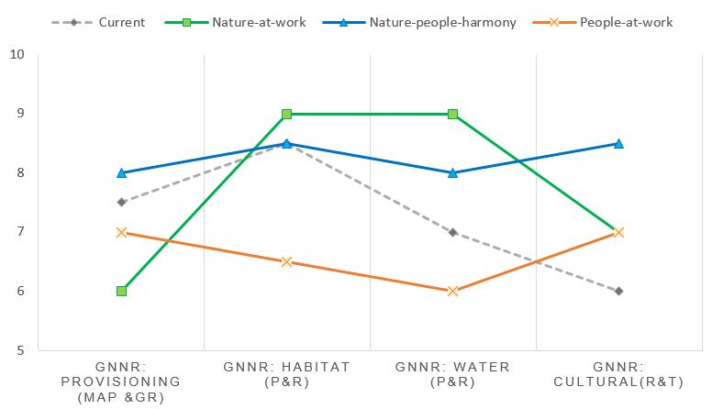

**Fig. 7.** Performance of four prioritized services under three plausible scenario

**5. Discussion**

Operationalization of the ecosystem services perspective for PA management requires stakeholders to take into account spatial aspect of service supply and demand (Dirk et al., 2015), and understand trade offs among the services (Turkelboom et al., 2018). IPBES (2019) highlight importance of environmental interactions and their economics over distances for sustainable development. While the participatory mapping outlined the extent of ecosystem services from PAs in the landscape, it also helped participants realize the importance of interregional flow of services (Schröter et al., 2019) – therefore the prospect of regional cooperation to sustain the delivery of services. . We discuss regional implications of ecosystem services for the transboundary landscape management by analyzing i) usefulness of SPHs, SBAs and dSPHs for effective regional scale PA planning, and ii) types of cooperation pathways for long term sustenance of ecosystem services in the landscape.

.

**5.1 Extent of SPHs, SBA, and dSPHs and spatial planning for PAs**

The extent of provisioning, regulating, cultural, and supporting services identified from the three PAs substantiate that PAs are able to safeguard both biodiversity and various environmental, socio-cultural, and economic services that benefit people (Smit et al., 2017). The above average score for current condition of four prioritized ecosystem services (see figure 7) reflect a good relationships between maintenance of ecosystem and services provisions (Burkhard et al, 2012). Ecosystems in the GNNR have been maintained through strict PA governance and research and monitoring efforts (Allendorf & Yang, 2013). There is dual protection status and varied conservation interventions for park and buffer areas for NNP-TR, and entire northern Myanmar forest complex is maintained as protected landscape in HKNP. However, further research on the underlying ecological functions and relationships between intermediary processes and services are needed to further strengthen PA management commitment by countires (Schirpke et al 2017).

The Individual PCA bioplot (Figure 8) validates participant’s perceptions on source and sink areas of services. Degradation of SPHs related to habitat services (HdSPHs), and SBAs for cultural (CSBAs), Water (WSBAs), and Habitat (HSBAs) services - positive to PC2 and PC1 respectively imply that they strongly influence the delivery of ecosystem services. The dSPHs related to habitat services (HdSPHs) for NNP-TR substantiate the unsustainable transformation of PAs (Datta et al., 2008) as a result of multitude of factors as identified by the participants such as landuse change and land erosion, population growth, habitat encroachment, agricultural expansion, coal mining, haphazard extraction of resources, and illegal hunting and trade. The SBAs and SPHs for cultural services (CSBAs, CSPHs) confer that PA management in the landscape need to also consider bio-culturally sensitive areas outside PAs, as they enhance aesthetic and knowledge value of the PAs (Ament et al., 2016). For NNP-TR, although the state policy are sensitive to the traditional rights of indigenous community, this has negatively influenced habitat regulation services, with increased encroachment even in the core zones (Arunachalam et al., 2004). Integrated landscape management will be fundamental here in addressing ethnic land use tenure challenge and minimize habitat encroachment and deforestation. The degradation of SPHs for cultural services (CdSPHs) and SBAs for provisioning services for HKNP – both positive to PC1 justify their importance for enhancement of services from PAs. For HKNP, SPHs and dSPHs for water strongly positive to PC1 highlight the importance of the PA being the water tower for the entire country. The watershed and forests in the PAs have received strong national conservation priority, and with its remote location and low population density among ethnic communities living in and around the PAs, currently, all services have been maintained well (Tun, 2001), however cultural services are most compromised given the socio-political conflicts in the region (Renner et al., 2007). For GNNR, habitat services along with provisioning services related to genetic resources and medicinal and aromatic plants are very strong compared to water regulation/provisioning and cultural services- therefore appear negative to both PC1 and PC2. 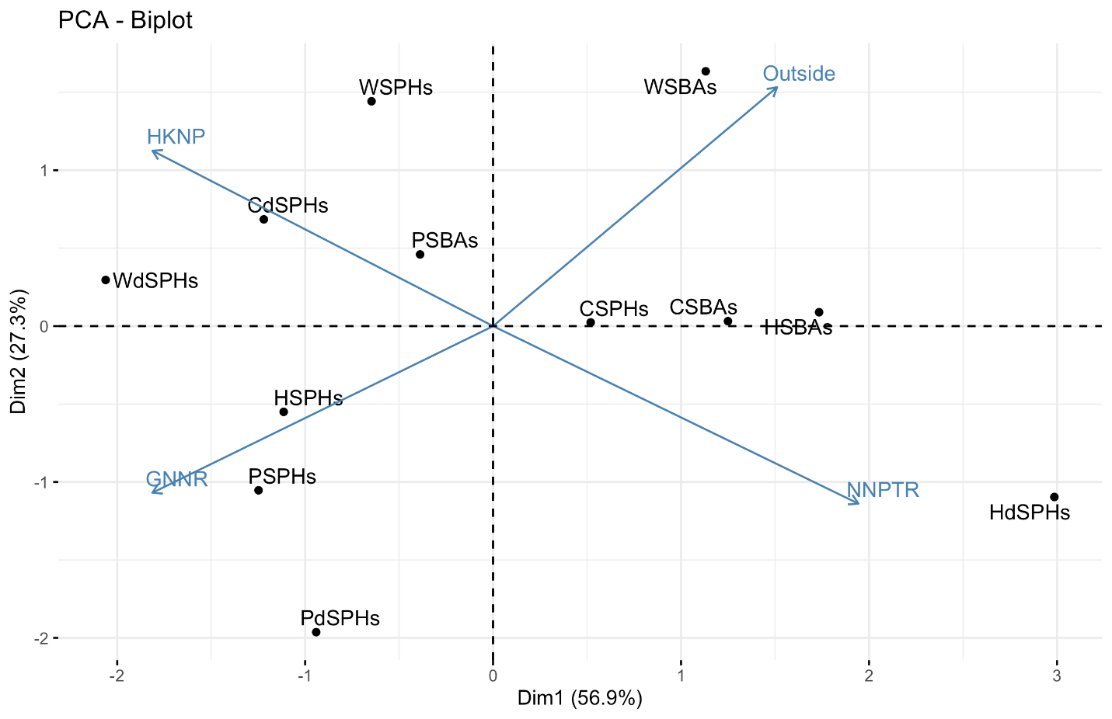

**Fig. 8.** Individual PCA biplot showing relationships of SPHs, SBAs and dSPHS in the three PAs.

Coming to future direction, the Nature-People-Harmony scenario reflects more holistic multifunctional landscape services concept (Rodríguez-Loinaz et al., 2015) allowing governments in the three countries to put equal emphasis to environmental, cultural, and economic objectives and minimize trade-offs among multiple services driven by management strategies (McShane et al, 2011) or by value dimensions (Martín-López et al., 2014). The scenario, as depicted by the participants considered development aspiration of community in and around PAs and promoted other aesthetic, recreation, knowledge and education related cultural services in the landscape. The current situation in HKNP with better habitat and water regulation services more or less reflect this adaptive scenario (figure 8). The balance between environmental conservation and economic development of indigenous communities, and communities-led resource management remain fundamental to cater to several dSPHs that overlap with SBAs, or SPHs outside the PAs that represent areas of rich biodiversity nurtured by traditions and cultures of ethnic communities (Allendorf & Yang, 2013). Such functional spatial units with distinct socio-ecological characters have been considered important for ecosystem services based decision making especially in the mountain landscape ( Schirpke et al., 2020). The other two - Nature-at-Work and People-at-Work scenarios relate to situations when conservation and development policies are not aligned and incur greater trade-offs.

**5.2 Cooperation pathways to manage multiple services**

Biodiversity is integral to the socio-cultural and economic well-being of people in the Far-eastern Himalayan landscape where majority of rural populations rely on biodiversity dependent livelihoods (Rerkasem et al., 2002; Rao et al., 2011). PAs here are meant to preserve nature and interaction between nature and human, including social assets in nature (Hummel et al, 2019). However, important realization is that benefits and services from biodiversity in the form of ecosystem services relate to beneficiaries ranging from communities in and around PAs to stakeholders in distant locations within each country or in different countries (Figure 9). This implies that stakeholders value judgement and power stakes become crucial in maintaining the services (Felipe-Lucia et al., 2015). Participatory mapping and scenario development while they helped consolidate stakeholders’ diverse perspectives on use value of PAs, they also imparted knowledge that i) protected areas have complex spatial relationships between source and sink areas for ecosystem services (Schirpke et al 2014); ii) The four ecosystem services are maintained at above average conditions currently with higher percentage of SPHs compared to SBAs, but their vulnerabilities remain which calls for understanding of common pressures and interactions among ecosystem services (Bennett et al., 2009); and iii) there are obvious trade-offs in managing multiple ecosystem services and adaptive PA management can help mitigate longer term trade-offs resulting from stakeholder diverse influence on ecosystems (Turkelboom, 2018).

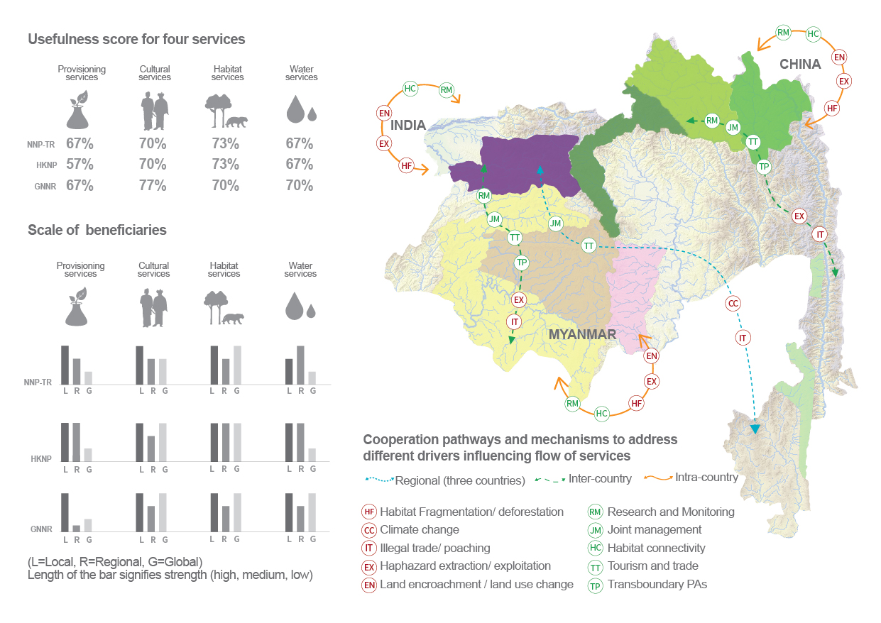

SBAs

SPHs

dSPHs

NNP-TR

HKNP

GNNR

Kamlang Wildlife Sanctuary

Southern extension of HKNP

Hukwang valley wildlife Sanctuary

Hponkanrazi wildlife Sanctuary

**Figure 9.** Regional implications of the flow of services showing extent of beneficiaries, usefulness for four services in each PAs and the types of cooperation pathways that addresses different drivers affecting ecosystem services.

Importantly, the four ecosystem services of high management priority in Landscape also show interregional connect, with SBAs of all the services reaching to beneficiaries beyond PAs and across the landscape. There are several globally important species which use wider habitat across the national boundaries (Uddin et al., 2019) thus have their SPHs and SBAs distributed in more than one protected areas or even outside in the landscape. The informal and formal trade between China and Myanmar for medicinal plants and wildlife products, exchange of knowledge, traditions and culture among ethnic communities in the landscape, shared habitats for globally threatened species, shared water services of Ayeywardy river are other examples of SPHs-SBAs connect in the landscape (Rao et al, 2011). These interregional connect of services mean that degradation of one SPHs can influence SBAs in distant locations (Schirpke et al., 2019), and that action in one PAs in one nation brings consequences for ecosystem services in other country (Howe et al, 2014). For example, when buyers on China’s eastern seaboard drove timber business along the Yunnan-Myanmar border, the intensity of logging in northern Myanmar significantly increased, this quickly depleted timber resources that could be cost-effectively harvested, affecting both Myanmar timber products and livelihoods of stakeholders across market chain (Kahrl, 2004).

The PAs in the three countries, while they have reasonable PA governance for protection of flagship species and other globally endangered species, the management focus needs to shift towards integrated landscape approach (Sayer et al 2010) that consider multifunctional landscape planning (Minang et al., 2015), and resilience of ecosystems and natural capital (Barbier, 2011). The government in the three countries need to see PAs as a part of wider landscape connecting biodiversity and ecosystem services from PAs to the landscape elements outside them (Brown et al., 2004), and connecting range of stakeholders with wider social values (Bryan et al., 2010). This enables protection of key biodiversity areas or SPHs located outside the current PA network, and reinforces ecological connectivity. Possible extension area extrapolated from the extent of SBAs, SPHs and dSPHs (Figure 9) shows close connection between NNP-TR and Kamlang Wildlife Sanctuary in the north. This spatial extension can increase ecological contiguity between the two PAs. The WHS nomination proposed for HKNP aims to include the southern extension of the landscape (UNESCO, 2014) - the justification of which is explicit when we consider the flow of ecosystem services. Between Myanmar and China, several dSPHs and SBAs that lie at the border of two nations open avenues for transboundary PAs (Trillo-Santamaría & Paül, 2016) that enhances cross border access and benefit sharing of the services (Schirpke et al 2019). It frames conservation in terms of mutual interests between countries considering diversity of stakeholders- managers and beneficiaries of services, and trade-offs between uses of multiple services (López-Hoffman et al., 2010).

Working across administrative and political boundaries calls for regional cooperation. Regional cooperation among the three countries facilitated through the Landscape Initiative for Far-eastern Himalayas (ICIMOD, 2019) provides this opportunity to discuss effective natural resource governance among the countries that generates both ecosystem services and livelihoods co-benefits in the entire landscape. We recommend regional, inter-country and intra-county cooperation pathways for long term maintenance of four priority services. These pathways build in spatial and temporal dependence of ES trade-offs (Rodriguez et al, 2013), and desirable management strategies able to simultaneously deliver multiple services (Bennett et al, 2009). Intra country pathway capitalizes on creating habitat links between PAs and priority SPHs outside through mechanisms such as creation of buffer zones, community conserved areas, and conservation/habitat corridors, and community based forestry and plantation of timber and fuelwood species. The provision of regulating services is sustainable when flow does not increase pressure in SPHs (Villamagna et al, 2013). This entails protection of currently unprotected SPHs such as the threatened rainforests of Naung Mung south and west of the current HKNP boundary that host most of the unique aspects of the region’s biodiversity (Rappole et al., 2005) and their management. Likewise, SPHs within the PAs with high dSPHs will need strong habitat restoration and economic valuation of services (Martín-lópez et al., 2011) to incentivize conservation actions (Bullock et al., 2011; Xu etal., 2019). Inter-country collaborative pathways build on common SPHs, SBAs and dSPHs between two countries and are meant to addresses sensitive cross border challenges such as poaching and illegal trade and transboundary ecosystem fragmentation (Liu et al., 2020), as well as promote positive scientific collaborations and joint management actions, engagement of communities across borders for collective conservation and conservation linked economic actions (Sandwith et al., 2001; Liu et al., 2020). Regional pathways focus on establishment of joint research and monitoring facilities and collaborative research programmes that ease biodiversity knowledge networking and information exchange between the countries (Eppink et al., 2012).

**6. Conclusions**

The results of this study reveal that PAs in the far-eastern Himalayan Landscape provide a diverse range of ecosystem services that reache beneficiaries beyond the park boundary or even beyond the boundary of one nation. The spatial extent of SPHs, SBAs and dSPHs, and their performance against three plausible future scenarios help visualize how PAs are placed in terms of maintaining different services, and how trade-offs between the services influence management of multiple ecosystem services. Participatory exercises, that were harmonized across the three PAs not only sensitized stakeholders in each countries on wider benefits and values of PAs, but also helped set the basis for regional cooperation between the countries. The regional implications were that in all three countries SPHs were located both within and outside of PAs and that future policy proposals for protected areas must integrate landuse outside PAs as conservation corridors, buffer zones, community forestry areas, and community conserved areas. For all the four prioritized ecosystem services, SBAs are also located at greater distance from SPHs indicating that the demand on the services are also regional and global. A landscape scale valuation of ecosystem services, and analysis of the cost of transfer of services to regional and global beneficiaries would allow the three countries explore incentive mechanisms for ecosystem services (Schirpke et al., 2017). Ecosystem services perspective allow countries to explore prospect of transboundary protected areas to collectively address common challenges degrading the SPHs along the border areas, and maintain the long term health and resilience of ecosystems, and the vitality of societies and stakeholders across the landscape.

**Acknowledgements**

The authors wish to thank all experts and resource persons who participated in the national workshops in China (at Kunming), Myanmar (at Nay Pyi Taw) and India (at Itanagar). The workshop was facilitated by the Landscape Initiative for Far-eastern Himalayas (HI-LIFE)- a oint transboundary landscape initiative between the International Centre for Integrated Mountain Development and partners in the China, India and Myanmar, and we gratefully acknowledge all core donors supporting ICIMOD/HI-LIFE. We are very thankful to the two reviewers for their critical but insightful comments. Last, but not least we thank Mr Sudip Maharjan, ICIMOD for his help with figures and graphics.

**References**

Adhikari, D., Arunachalam, A., Majumder, M., Sarmah, R., & Khan, M. L. (2003). A rare root parasitic plant (Sapria himalayana Griffith.) in Namdapha National Park, northeastern India. *Current Science*, *85*(12), 1668–1669. Retrieved from https://www.scopus.com/inward/record.uri?eid=2-s2.0-4544355618&partnerID=40&md5=32e3b628a1e6af2da75d7d845d59c66b

Allendorf, T. D., & Yang, J. (2013). The role of ecosystem services in park-people relationships: The case of Gaoligongshan Nature Reserve in southwest China. *Biological Conservation*, *167*, 187–193. https://doi.org/10.1016/j.biocon.2013.08.013

Ament, J. M., Moore, C., Herbst, M., African, S., Parks, N., & Cumming, G. S. (2016). *Cultural Ecosystem Services in Protected Areas : Understanding Bundles , Cultural Ecosystem Services in Protected Areas : Understanding Bundles , Trade-Offs , and Synergies*. (October). https://doi.org/10.1111/conl.12283

Arunachalam, A., Sarmah, R., Adhikari, D., Majumder, M., & Khan, M. L. (2004). Anthropogenic threats and biodiversity conservation in Namdapha nature reserve in the Indian Eastern Himalayas. *Current Science*, *87*(4), 447–454. Retrieved from https://www.scopus.com/inward/record.uri?eid=2-s2.0-9744248858&partnerID=40&md5=bae9aaa58df210740c5b2d770c51721c

Bagstad, K. J., Johnson, G. W., Voigt, B., & Villa, F. (2013). Spatial dynamics of ecosystem service flows: A comprehensive approach to quantifying actual services. *Ecosystem Services*, *4*, 117–125. https://doi.org/10.1016/j.ecoser.2012.07.012

Barbier, E. B. (2011). Pricing nature. In *Capitalizing on Nature: Ecosystems as Natural Assets*. https://doi.org/https://doi.org/10.1017/CBO9781139014922

Behera, M. D., Kushwaha, S. P. S., & Roy, P. S. (2002). *High plant endemism in an Indian hotspot - Eastern Himalaya High plant endemism in an Indian hotspot – eastern*. (May 2014). https://doi.org/10.1023/A

Braat, L. C., & Groot, R. De. (2012). The ecosystem services agenda : bridging the worlds of natural science and economics , conservation and development , and public and private policy. *Ecosystem Services*, *1*(1), 4–15. https://doi.org/10.1016/j.ecoser.2012.07.011

Bryan, B. A., Raymond, C. M., Crossman, N. D., & Hatton, D. (2010). Targeting the management of ecosystem services based on social values : Where , what , and how ? *Landscape and Urban Planning*, *97*, 111–122. https://doi.org/10.1016/j.landurbplan.2010.05.002

Bullock, J. M., Aronson, J., Newton, A. C., Pywell, R. F., & Rey-benayas, J. M. (2011). Restoration of ecosystem services and biodiversity : conflicts and opportunities. *Trends in Ecology and Evolution*, *26*(10), 541–549. https://doi.org/10.1016/j.tree.2011.06.011

Chan, K. M. A., Shaw, M. R., Cameron, D. R., Underwood, E. C., & Daily, G. C. (2006). Conservation Planning for Ecosystem Services. *PloS Biology*, *4*(11), 2138–2152. https://doi.org/10.1371/journal.pbio.0040379

Chape S, Harrison J, Spalding M, L. I. (2005). Measuring the extent and effectiveness of protected areas as an indicator for meeting global biodiversity targets. *Philosophical Transactions of the Royal Society B-Biological Sciences*, *360*(1454), 443–455.

Coad, L., Burgess, N. D., Bertzky, B., Commission, E., & Harvest, T. (2012). *Progress Towards the Convention on Biological Diversity ’ s 2010 and 2012 Targets for Protected Area Coverage A technical report for the IUCN international workshop “ Looking to*. (January 2015).

Dirk, V., Jan, S., Tom, V., Tom, D. H., Robyn, J., Moses, M., & Clovis, K. (2015). Reference : Mapping ecosystem service flows with land cover scoring maps for data-scarce regions . *Ecosystem Services*, *13*, 28–40. https://doi.org/10.1016/j.ecoser.2014.11.005

Eppink, F. V, Werntze, A., Mäs, S., Popp, A., & Seppelt, R. (2012). *Land Management and Ecosystem Services*. *1*, 55–63.

Felipe-Lucia, M. R., Martín-López, B., Lavorel, S., Berraquero-Díaz, L., Escalera-Reyes, J., & Comín, F. A. (2015). Ecosystem services flows: Why stakeholders’ power relationships matter. *PLoS ONE*, *10*(7). https://doi.org/10.1371/journal.pone.0132232

Fisher, B., Turner, R., & Morling, P. (2009). Defining and classifying ecosystem services for decision making. *Ecological Economics*, *68*, 643–653. https://doi.org/10.1016/j.ecolecon.2008.09.014

González-García, A., Palomo, I., González, J. A., López, C. A., & Montes, C. (2020). Quantifying spatial supply-demand mismatches in ecosystem services provides insights for land-use planning. *Land Use Policy*, *94*. https://doi.org/10.1016/j.landusepol.2020.104493

Guerry, A. D., Polasky, S., Lubchenco, J., Chaplin-kramer, R., & Daily, G. C. (2015). *Natural capital and ecosystem services informing decisions : From promise to practice*. *112*(24). https://doi.org/10.1073/pnas.1503751112

Hummel, C., Poursanidis, D., Orenstein, D., Elliott, M., Adamescu, M. C., Cazacu, C., … Hummel, H. (2019). Protected Area management: Fusion and confusion with the ecosystem services approach. *Science of the Total Environment*, *651*, 2432–2443. https://doi.org/10.1016/j.scitotenv.2018.10.033

Hummel, D., Jahn, T., Keil, F., Liehr, S., & Stieß, I. (2017). Social ecology as critical, transdisciplinary science-conceptualizing, analyzing and shaping societal relations to nature. *Sustainability (Switzerland)*, *9*(7). https://doi.org/10.3390/su9071050

Jessica Brown, N. M. and M. B. (Ed.). (2004). *The Protected Landscape Approach Linking Nature, Culture and Community*. Gland, Switzerland and Cambridge, UK.: IUCN.

Kissinger, M., Rees, W. E., & Timmer, V. (2011). Interregional sustainability: governance and policy in an ecologically interdependent world. *Environmental Science & Policy*, *14*(8), 965–976. https://doi.org/https://doi.org/10.1016/j.envsci.2011.05.007

Koellner, T., Bonn, A., Arnhold, S., Bagstad, K. J., Fridman, D., Guerra, C. A., … Schröter, M. (2019). Guidance for assessing interregional ecosystem service flows. *Ecological Indicators*, *105*, 92–106. https://doi.org/10.1016/j.ecolind.2019.04.046

Lan, D., & Dunbar, R. (2000). Bird and mammal conservation in Gaoligongshan Region and Jingdong County, Yunnan, China: Patterns of species richness and nature reserves. *ORYX*, *34*(4), 275–286. https://doi.org/10.1046/j.1365-3008.2000.00131.x

Liu, J., Yong, D. L., Choi, C., & Gibson, L. (2020). Transboundary Frontiers : An Emerging Priority for Biodiversity Conservation. *Trends in Ecology & Evolution*, *xx*(xx), 1–12. https://doi.org/10.1016/j.tree.2020.03.004

Lodhi, M. S., & Samal, P. K. (2013). *Land Cover Mapping for Namdapha National Park ( Arunachal Pradesh ), India Using Harmonized Land Cover Legends*. (June). https://doi.org/10.1007/s12524-013-0326-8

López-Hoffman, L, Varady, R. G., Flessa, K. W., & Balvanera, P. (2010). Ecosystem services across borders: A framework for transboundary conservation policy. *Frontiers in Ecology and the Environment*, *8*(2), 84–91. https://doi.org/10.1890/070216

López-Hoffman, Laura, Varady, R. G., Flessa, K. W., & Balvanera, P. (2010). Ecosystem services across borders: A framework for transboundary conservation policy. *Frontiers in Ecology and the Environment*, *8*(2), 84–91. https://doi.org/10.1890/070216

Martín-lópez, B., García-llorente, M., Palomo, I., & Montes, C. (2011). The conservation against development paradigm in protected areas : Valuation of ecosystem services in the Doñana social – ecological system ( southwestern Spain ). *Ecological Economics*, *70*(8), 1481–1491. https://doi.org/10.1016/j.ecolecon.2011.03.009

Millennium EcosystemAssessment. (2005). *Ecosystems AND HUMAN WELL-BEING*.

Minang, P. A., Noordwijk, M. Van, Freeman, O. E., Mbow, C., Leeuw, J. De, & Catacutan, D. (Eds.). (2015). *Climate-Smart Landscapes : Multifunctionality in Practice*. Nairobi, Kenya: World Agroforestry Centre (ICRAF).

Palomo, I., Martín-López, B., López-Santiago, C., & Montes, C. (2011). Participatory scenario planning for protected areas management under the ecosystem services framework: The Doñana social-ecological system in Southwestern Spain. *Ecology and Society*, *16*(1). https://doi.org/10.5751/ES-03862-160123

Palomo, I., Martín-López, B., Potschin, M., Haines-Young, R., & Montes, C. (2013). National Parks , buffer zones and surrounding lands : Mapping ecosystem service flows. *Ecosystem Services*, *4*, 104–116. https://doi.org/10.1016/j.ecoser.2012.09.001

Rao, M., Zaw, T., Htun, S., & Myint, T. (2011). Hunting for a Living: Wildlife Trade, Rural Livelihoods and Declining Wildlife in the Hkakaborazi National Park, North Myanmar. *Environmental Management*, *48*(1), 158–167. https://doi.org/10.1007/s00267-011-9662-z

Raymond, C. M., Bryan, B. A., Hatton, D., Cast, A., Strathearn, S., Grandgirard, A., & Kalivas, T. (2008). Mapping community values for natural capital and ecosystem services. *Ecological Economics*, *68*(5), 1301–1315. https://doi.org/10.1016/j.ecolecon.2008.12.006

Renner, S. C., Rappole, J. H., Leimgruber, P., Kelly, D. S., Shwe, N. M., Aung, T., & Aung, M. (2007). Land cover in the northern forest complex of Myanmar: New insights for conservation. *ORYX*, *41*(1), 27–37. https://doi.org/10.1017/S0030605307001603

Rerkasem, K., Yimyam, N., Korsamphan, C., Thong-Ngam, C., & Rerkasem, B. (2002). Agrodiversity Lessons in Mountain Land Management. *Mountain Research and Development*, *22*(1), 4–9. https://doi.org/10.1659/0276-4741(2002)022{[}0004:ALIMLM]2.0.CO;2

Rodríguez-Loinaz, G., Alday, J. G., & Onaindia, M. (2015). Multiple ecosystem services landscape index: A tool for multifunctional landscapes conservation. *Journal of Environmental Management*, *147*, 152–163. https://doi.org/10.1016/j.jenvman.2014.09.001

Sandwith, T., Shine, C., Hamilton, L., & Sheppard, D. (2001). *Protected areas for peace and co-operation*. Retrieved from http://web.bf.uni-lj.si/students/vnd/knjiznica/Skoberne_literatura/gradiva/zavarovana_obmocja/IUCN_TBPA.pdf

Schirpke, U, Tappeiner, U., & Tasser, E. (2019). A transnational perspective of global and regional ecosystem service flows from and to mountain regions. *Scientific Reports*, *9*(1). https://doi.org/10.1038/s41598-019-43229-z

Schirpke, Uta, Marino, D., Marucci, A., Palmieri, M., & Scolozzi, R. (2017). Operationalising ecosystem services for effective management of protected areas : Experiences and challenges. *Ecosystem Services*, *28*, 105–114. https://doi.org/10.1016/j.ecoser.2017.10.009

Schirpke, Uta, Schirpke, U., Leitinger, G., Tasser, E., Rüdisser, J., & Fontana, V. (2020). Functional spatial units are fundamental for modelling ecosystem services in mountain regions Functional spatial units are fundamental for modelling ecosystem services in mountain regions. *Applied Geography*, *118*(April), 102200. https://doi.org/10.1016/j.apgeog.2020.102200

Schirpke, Uta, Scolozzi, R., Marco, C. De, & Tappeiner, U. (2014). *Mapping bene fi ciaries of ecosystem services fl ows from Natura 2000 sites*. *9*, 170–179. https://doi.org/10.1016/j.ecoser.2014.06.003

Schirpke, Uta, Tappeiner, U., & Tasser, E. (2019). A transnational perspective of global and regional ecosystem service flows from and to mountain regions. *Scientific Reports*, *9*(1), 6678. https://doi.org/10.1038/s41598-019-43229-z

Schröter, M, Koellner, T., Alkemade, R., Arnhold, S., Bagstad, K. J., Erb, K.-H., … Bonn, A. (2018). Interregional flows of ecosystem services: Concepts, typology and four cases. *Ecosystem Services*, *31*, 231–241. https://doi.org/10.1016/j.ecoser.2018.02.003

Schröter, M, Kraemer, R., Remme, R. P., & van Oudenhoven, A. P. E. (2019). Distant regions underpin interregional flows of cultural ecosystem services provided by birds and mammals. *Ambio*. https://doi.org/10.1007/s13280-019-01261-3

Schröter, Matthias, Koellner, T., Alkemade, R., Arnhold, S., Bagstad, K. J., Erb, K., … Bonn, A. (2018). *Interregional flows of ecosystem services : Concepts , typology and four cases*. *31*(November 2017), 231–241. https://doi.org/10.1016/j.ecoser.2018.02.003

Serna-Chavez, H. M., Schulp, C. J. E., Van Bodegom, P. M., Bouten, W., Verburg, P. H., & Davidson, M. D. (2014). A quantitative framework for assessing spatial flows of ecosystem services. *Ecological Indicators*, *39*, 24–33. https://doi.org/10.1016/j.ecolind.2013.11.024

Smit, I. P. J., Roux, D. J., Swemmer, L. K., Boshoff, N., & Novellie, P. (2017). Protected areas as outdoor classrooms and global laboratories: Intellectual ecosystem services flowing to-and-from a National Park. *Ecosystem Services*, *28*, 238–250. https://doi.org/10.1016/j.ecoser.2017.05.003

Srinivasan, U., Dalvi, S., Naniwadekar, R., Anand, M. O., & Datta, A. (2010). The birds of Namdapha National Park and surrounding areas: Recent significant records and a checklist of the species. *Forktail*, (26), 92–116. Retrieved from https://www.scopus.com/inward/record.uri?eid=2-s2.0-78651332408&partnerID=40&md5=ccda21573b487bc6394efa8b0a5bef6b

Syrbe, R.-U., & Grunewald, K. (2017). Ecosystem service supply and demand–the challenge to balance spatial mismatches. *International Journal of Biodiversity Science, Ecosystem Services and Management*, *13*(2), 148–161. https://doi.org/10.1080/21513732.2017.1407362

Trillo-Santamaría, J. M., & Paül, V. (2016). Transboundary protected areas as ideal tools? Analyzing the Gerês-Xurés transboundary biosphere reserve. *Land Use Policy*, *52*, 454–463. https://doi.org/10.1016/j.landusepol.2015.12.019

Tun, N. (2001). Conservation Approach to the Wildlife Survey in the Hkakaborazi National Park , Northern Myanmar The National Park is located in Naung Mung Township , Putao District. *Journal of Myanmar Academic and Technology*, (1), 11–21.

Turkelboom, F., Leone, M., Jacobs, S., Kelemen, E., García-Llorente, M., Baró, F., … Rusch, V. (2018). When we cannot have it all: Ecosystem services trade-offs in the context of spatial planning. *Ecosystem Services*, *29*, 566–578. https://doi.org/https://doi.org/10.1016/j.ecoser.2017.10.011

Uddin, K., Chettri, N., Yang, Y., Lodhi, M. S., Htun, Z., & Sharma, E. (2019). Integrating geospatial tools and species for conservation planning in a data-poor region of the Far Eastern Himalayas. *Geology, Ecology, and Landscapes*, *00*(00), 1–16. https://doi.org/10.1080/24749508.2019.1610840

Villamagna, A. M., Angermeier, P. L., & Bennett, E. M. (2013). Capacity , pressure , demand , and flow : A conceptual framework for analyzing ecosystem service provision and delivery. *Ecological Complexity*, *15*, 114–121. https://doi.org/10.1016/j.ecocom.2013.07.004

Xu, J., Xiao, Y., Xie, G., Wang, Y., & Jiang, Y. (2019). Computing payments for wind erosion prevention service incorporating ecosystem services flow and regional disparity in Yanchi County. *Science of the Total Environment*, *674*, 563–579. https://doi.org/10.1016/j.scitotenv.2019.03.361

Young, J. C., Jordan, A., R. Searle, K., Butler, A., S. Chapman, D., Simmons, P., & Watt, A. D. (2013). Does stakeholder involvement really benefit biodiversity conservation? *Biological Conservation*, *158*, 359–370. https://doi.org/https://doi.org/10.1016/j.biocon.2012.08.018

Zhang, L., (2015). Balancing conservation and development to preserve China’s biodiverity. *Conservation Biology, 29,* 1496-1496.